🡪 **Action for Question – (a)**

Here I’m performing data cleaning on a given dataset, which contains car’s related data, here my goal is to handle missing values, below screenshot shows the missing values in the dataset.

Also, this dataset contains both numerical and categorical type of data.

Also, by observing the above screenshot only the numerical columns have missing values.

Moreover, ‘New_Price’ column has more missing values.

To handle this approach first I tried to handle the missing values other than ‘New_Price’ column, for ‘categorical columns’ I choose to impute with ‘mode’, and for ‘numerical columns’ I choose to impute with ‘median’.

Once this completes, now started working with the ‘New_Price’ column. Here, I observed that, for the given dataset total number of rows were ‘5847’, from these many rows ‘5032’ rows were missing for this ‘New_Price’ column (i.e., around 86% of the rows are missing). So, in this case I choose to drop that column for further analysis.

After all this, the missing values count of the dataset is as below,

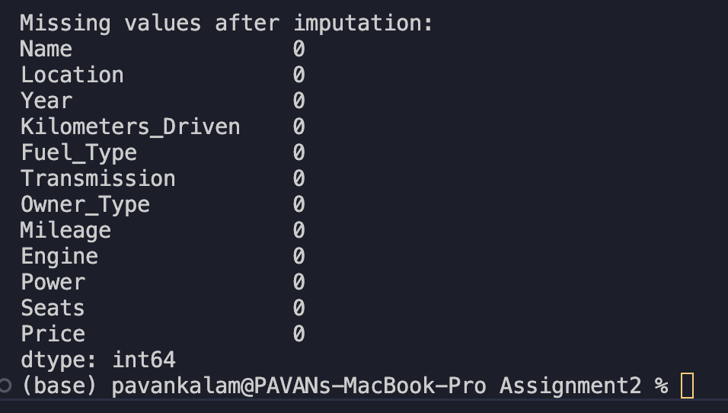

This is the action which I took for this task (Question-a)